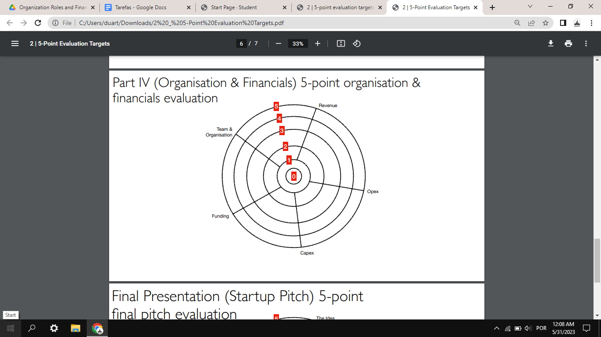

Revenue: Midas

Opex (Operational Expenditure): Fábio

Capex (Despesa de capital): Manel

Funding: Duarte

Team & Organisation: André

Apresentação: Fábio, André

##### After having identified a problem/need that needed to be addressed in the world, having proposed a new, more innovative solution to address it, and having estimated the size of the market to be addressed, it is time to define the organization of the startup, to design the financial plan for its development in the first 5 years, and to determine the amount of funding that could be the subject of a venture capital investment.

The organization, the financial plan, and the funding needed are a consequence of what the startups have defined for the products or services they want to develop and deploy, and for the markets they want to sell to. Please make sure that as you dive into the organization and the financial plan of your startup, there is consistency with all you have already said for the development of your startup.

[Financial Projection Template for Startups - Brixx](https://brixx.com/financial-plan-template/)

Operating Expense (OPEX) = Salaries + Sales Commissions + Promotional & Advertising Cost + Rental Expense + Utilities

**Capital Expenditures (CAPEX)**

* Property, plant and equipment (PP&E);
* Longevity is one defining feature of a CAPEX investment (more than one tax year);
* Examples:
  + Manufacturing plants, equipment, and machinery;
  + Building improvements;
  + Computers;
  + Vehicles and trucks.
* Can be externally financed, which is usually done through [collateral](https://www.investopedia.com/terms/c/collateral.asp) or [debt financing](https://www.investopedia.com/terms/d/debtfinancing.asp).

**Funding**

Startup incubators are specialized hubs that can help early-stage ventures and startups navigate some of the most challenging aspects of running a business.

A startup accelerator is a mentor-based program that provides guidance, support and limited funding in exchange for equity.

Select a startup accelerator that is wellsuited for your product, or a better choice may be going with no accelerator.

Portugal

Portugal Ventures

Tickets between 50k€ and 1.5M€ depending on the sector and stage

We hold a minority stake in the company’s share capital

We have a seat on the company’s Board of Directors

### ONLINE APPLICATION - Submit your application in our website

-Calls

-Open day registrations (every month except August) - algumas das informações necessárias:

* Is the company incorporated? If yes, please indicate in which region of Portugal.
* Today, what is the size of your team?
* What is your company's turnover (the total amount of sales)
* Is your project/company incubated in any accelerator, incubator, association, cluster technophiles, university
* In which stage is your project/company? (Prototype, Proof of Concept, Validation to product-market-fit or MVP with the first clients)
* What is the total investment required for the project? (in euros)
* What is the estimated amount for the entry of a venture capital operator? (in euros)
* Please include a presentation of the project / company - basicamente o que temos feito nesta cadeira

### PRE-SCREENING - Feedback from submissions in 15 working days by the Portugal Ventures team.

### PANEL OF EXPERTS - After a positive feedback from Portugal Ventures’ investment team, startups do a pitch to international and national experts and receive their recommendations.

### EVALUATION - Detailed evaluation from our investment team; startups are invited to do a pitch to our board.

### EVALUATION - Detailed evaluation from our investment team; startups are invited to do a pitch to our board.

### CONTRACT -Contracts and closing.